**H.O.D CERTIFICATE**

This is to certify that,

Miss. Priya Shivling Koneri, Miss. Supriya Krishnat Kumbhar, Miss. Pradnya Arun Mali and Miss. Mrunali Maruti Patil have satisfactorily completed the project work entitled "**Online web portal for Green Metrics Calculations and Analysis** " for Vivekanand College, Kolhapur (Empowered Autonomous) as a partial fulfilment of the course B.Sc. in Computer Science of Shivaji University, Kolhapur for academic year 2023-24. To the best of my knowledge and belief, the project presented by them is original work and is not copied from any source.

**Date:** 13/03/2024

**Place:** Kolhapur

Dr. V. B. Waghmare

(H.O.D of Computer Science Department)

﻿

**ACKNOWLEGEMENT**

We extend our heartfelt gratitude to Dr. V. B. Waghmare and Dr. I. K. Mujawar for their valuable guidance and insightful suggestions, which significantly contributed to the successful completion of this project.

We also extend our gratitude to Dr.Arjun Kumbhar and Ms.Archana Rajmane, whose profound explanations, guidance, and unwavering assistance were invaluable throughout the entirety of this project. Their expertise and dedication significantly contributed to its successful completion.

We are deeply indebted to our supervisor, Dr. R. Y. Patil, whose unwavering support, constructive feedback, and encouragement played a pivotal role in shaping this endeavor. Her expertise and mentorship were instrumental in navigating through the complexities of the project.

 Special thanks are due to the faculty and staff of the Computer Science Department, whose support, expertise, and resources facilitated the smooth progress of our project. Their assistance, whether direct or indirect, has been instrumental in achieving our goals.

Lastly, we extend our gratitude to all those who, in various ways, contributed to this project, whether through discussions, technical assistance, or moral support. Your collective efforts have made this endeavor possible and enriched our learning experience.

Miss. Priya Shivling Koneri                                                       Miss. Pradnya Arun Mali

Miss. Supriya Krishnat Kumbhar                                              Miss. Mrunali Maruti Patil

**DECLARATION**

Το

The Principal,

Vivekanand College (Empowered Autonomous),

Kolhapur

We undersigned declare that the project report on "**Online web portal for Green Metrics Calculations and Analysis**" is developed by us.

This project work is completed under the guidance of Dr. R. Y. Patil. The findings in this project are based on data collected by us. We understand that any such copying is liable to be punished in a way the college authorities deem it.

**Date:** 13/03/2024

**Place:** Kolhapur

Miss. Priya Shivling Koneri Miss. Pradnya Arun Mali

Miss. Supriya Krishnat Kumbhar Miss. Mrunali Maruti Patil

**GUIDE CERTIFICATE**

This is to certify that,

Miss. Priya Shivling Koneri, Miss. Supriya Krishnat Kumbhar, Miss. Pradnya Arun Mali and Miss. Mrunali Maruti Patil have statisfactorily carried out the project work entitled on “**Online web portal for Green Metrics Calculations and Analysis**” for Vivekanand College, Kolhapur (Empowered Autonomous) as partial fulfilment of course BSc. In Computer Science of Shivaji University, Kolhapur for academic year 2023-2024. To best of my knowledge and belief the project presented by them is the original work and not copied from any source.

Date : 13/03/2024

Place : Kolhapur

Dr. R. Y. Patil

(Project Guide)

**INDEX**

|  |  |
| --- | --- |
| **TITLE** | **PAGE NO** |
| **1.INTRODUCTION**  1.1 Introduction  1.2 System Analysis  1.2.1 Purpose of the project  1.2.2 Existing System |  |
| **2.PROPOSED SYSTEM**  2.1Proposed System  2.2 Objectives  2.3 Development Methodology |  |
| **3.SYSTEM DIAGRAMS**  3.1 Data Flow Diagram(0 level)  3.2 Entity Relationship Diagram (ERD)  3.3 Use Case Diagram  3.4 Project Flowchart Diagram |  |
| **4. SYSTEM DESIGN**  4.1 Database Design  4.2 Input Screen  4.3 Output Screen  4.4 Reports |  |
| **5. LIMITATIONS** |  |
| **7. CONCLUSION** |  |
| **8. BIBLIOGRAPHY** |  |

**INTRODUCTION**

**1.1 Introduction:**

The **"Online Web Portal for Green Metrics Calculations and Analysis"** is a software project designed to calculate green metrics calculations easily. By harnessing the power of technology, this project aims to provide users with a robust and user-friendly solution for measuring, analysing, and reducing their environmental footprints.

The chemistry department has been conducting research on the "GREEN METRICS," and the challenging aspect of their research has been performing 15-20 calculations for each chemical product. Thus, with this project, we have created software that has made these chemical green metrics calculations easier and faster. Green chemistry metrics have been described as aspects of a chemical process relating to the principles of Green Chemistry.

The Green Metrics Analyser has been developed as a powerful tool to streamline the process of calculating and tracking various sustainability and environmental metrics. It is a web-based application that has automated and simplified complex calculations, making it easier for businesses, organizations, and individuals to assess their environmental impact and make informed decisions to reduce it.

One of the key advantages of the Green Metrics Calculator and Analyser has been its ability to save valuable time. Traditionally, calculating green metrics, such as carbon emissions, water usage, energy consumption, and waste generation, effective mass yield(EMY),Atom Economy(AE),Atom Efficiency(AEF),Carbon Efficiency(CE),Reaction Mass Efficiency (RME),Optimum Efficiency (OE),Product Mass Efficiency (PME),Mass Intensity (MI),Mass Productivity(MP),Environmental-Factor(E-Factor),Solvent-Intensity(SI),Water-Intensity(WI),Turn Over Number(TON),Turn Over Frequency(TOF) has been a time-consuming and labour-intensive process. However, the Green Metrics Calculator and Analyser has automated these tasks, significantly reducing the time and effort required for these green metrics calculations.

**1.2 System Analysis:**

* + 1. **Purpose of the Project**

The primary purpose of the Green Metrics Calculator and Analyser is to empower users to assess their environmental impact accurately and efficiently. By automating complex calculations related to green chemistry metrics, the software enables users to make informed decisions to minimize their carbon footprint, water usage, energy consumption, and waste generation. Whether used by research institutions, manufacturing companies, or individuals, the Green Metrics Calculator and Analyser serves as a valuable tool for promoting environmental sustainability and responsible resource management.

**Key Features:**

**1. Automated Calculations:** The Green Metrics Analyser automates the process of calculating various green chemistry metrics, eliminating the need for manual calculations and reducing the risk of errors.

**2. Comprehensive Analysis:** Users can conduct in-depth analyses of their environmental impact by measuring factors such as carbon emissions, water usage, energy consumption, and waste generation.

**3. Customizable Parameters:** The software allows users to customize input parameters based on their specific requirements and industry standards, ensuring accurate and relevant results.

**4. Data Visualization:** The Green Metrics Calculator and Analyser provides intuitive data visualization tools, allowing users to interpret and communicate their results effectively through charts, graphs, and reports.

**5. Scalability:** Whether used for individual projects or large-scale operations, the Green Metrics Calculator and Analyser is designed to accommodate varying levels of complexity and volume of calculations.

**Benefits:**

**1. Time Savings**: By automating complex calculations, the Green Metrics Calculator and Analyser saves the users valuable time and resources, allowing them to focus on strategic decision-making and sustainability initiatives.

**2. Accuracy:** The software ensures accuracy and consistency in environmental impact assessments, minimizing the risk of errors associated with manual calculations.

**3. Cost Efficiency:** By optimizing resource utilization and identifying areas for improvement, the Green Metrics Analyser helps organizations reduce operational costs and enhance overall efficiency.

**4. Environmental Guardianship**: By promoting awareness and accountability for environmental impact, the software encourages proactive measures to mitigate negative effects on the environment and promote sustainability.

**1.2.2Existing Systems:**

**These are the active existing systems:-**

|  |  |
| --- | --- |
| **Tool** | **Description** |
| **PMI Predictor** | Calculates process mass intensity (PMI) for a chemical synthesis route using the sequence of synthetic steps and step information. |
| **Chemotion** | Open Source electronic lab notebook for researchers with a green-chemistry. |
| **CHEM21 toolkit** | Evaluating sustainability of reactions, covering quantitative and qualitative criteria both upstream and downstream of the reaction itself. |

**Drawbacks of the above exiting systems are as follows:**

1. **Data Entry Burden**: Inputting all the required data and information into these systems can be time-consuming and labour-intensive, potentially slowing down research or project workflows.
2. **Limited Scope:** Some of these tools may have limitations in terms of the types of reactions, processes, or industries they can effectively evaluate, which might not cover all research needs.
3. **Cost:** Acquiring and implementing these systems may involve significant upfront costs, including software licenses, hardware, and training expenses. This cost factor can be a barrier for smaller research groups or organizations.

**To overcome the above drawbacks, we are developing a computerized “Green Metrics Calculator and Analyser”**

**PROPOSED SYSTEM**

**2.1 Proposed System:**

* In the proposed system, we have developed the **"Green Metrics Calculator and Analyser"** web portal for green metrics calculations and analysis.
* The aim of the proposed system has been to develop a system for Green metrics calculations and to measure the efficiency and environmental performance of chemical processes.
* The proposed system has been able to overcome the limitations of the existing system.
* Users have had the ability to generate customizable reports based on their specific needs and requirements, providing valuable insights into green metrics and process efficiency.
* The proposed system has automated chemical calculations, analysed multicomponent reactions, minimized errors in green metrics calculations, and provided graphical representation for data analysis.
* The system has featured an intuitive and user-friendly interface to ensure ease of use for both experts and non-experts in chemical engineering and environmental science.

**Development Environment:**

|  |  |
| --- | --- |
| ***Scripting Language*** | ***Python*** |
|  | Flask microweb-framework |
| Designing and Scripting Language | HTML, CSS, Java Script |
| DBMS Environment | MySQL |
| Open-Source Libraries | MySQL Connector, fpdf, matplotlib |

**2.2 Objectives**

* To assist users, including research institutions and manufacturing companies, in adhering to and exceeding environmental standards and regulations.
* To find the efficiency and yields of the multicomponent reactions.
* To minimize errors while performing green metrics calculations manually.
* To compare the various chemical processes and to choose best among them for further experimentation.
* To represent chemical process data graphically for better analysis.
* To design the software that helps to find chemical process for commercial purpose to identify areas where they can reduce waste and improve efficiency, ultimately leading to cost savings.

**Features:**

**1. Automates Calculations:** By automating green metrics calculations, the system will help minimize errors associated with manual calculations. Users can rely on the accuracy and consistency of automated calculations, reducing the risk of errors in environmental impact assessments

**2. Efficiency Measurement:** The system will allow users to measure the efficiency and environmental performance of chemical processes accurately. Through automated calculations and analysis, users can quantify the environmental impact of their processes in terms of factors such as carbon emissions, water usage, energy consumption, and waste generation.

**3. Multicomponent Reaction Analysis**: Users will be able to analyse the efficiency and yields of multicomponent reactions efficiently. The system will provide tools for conducting detailed assessments of reaction outcomes, identifying key parameters influencing yield and efficiency, and optimizing reaction conditions accordingly.

**4. Graphical Representation:** Users will have the ability to represent chemical process data graphically for better analysis and visualization. The system will offer a range of visualization tools, including charts, graphs, and dashboards, allowing users to interpret and communicate their results effectively.

**5. Cost Savings:** Through the optimization of chemical processes and the identification of areas for improvement, the system will contribute to cost savings for businesses and organizations. By reducing waste, minimizing resource consumption, and improving efficiency, users can achieve tangible cost benefits and enhance their competitive edge in the market.

**6. User-Friendly Interface**: The system will feature a user-friendly interface designed for ease of use and accessibility. Intuitive navigation, clear instructions, and interactive tools will ensure that users can efficiently leverage the system's capabilities without extensive training or technical expertise.

**2.3 Development Methodology:**

Development Methodology: **Waterfall Model for Green Metrics Project**

The Waterfall Model is a sequential and linear approach to software development that divides the project lifecycle into distinct phases. Each phase must be completed before the next phase begins, making it suitable for projects with well-defined requirements and objectives, such as the **Online Green Metrics Calculations and Analysis** project. Below is a breakdown of how the Waterfall Model can be applied to the development of the Green Metrics Analyser:

**1. Requirements Gathering:**

- In this initial phase, we have gathered detailed requirements from chemistry department and potential end-users. We gathered the calculations and formulas required for those calculation and their chemical products mass and molecular weight and understood how the formulae works and its importance.

Requirements will include specific functionalities, calculations, data visualization requirements, and user interface preferences.

**2. System Design:**

Once requirements were gathered and documented, the system architecture and design was planned. In this phase we defined the overall structure of the software, including the database schema, user interface layout, and system components .Detailed design documents, including flowcharts and diagrams were created to visualize the system's structure and functionality.

**3. Implementation:**

With the design in place, we proceeded to implement the software according to the specifications outlined in the requirements and design documents.

In this phase we implemented login and signup pages, then we developed the green metrics calculation page and along with that data submissions and display functionality was implemented. And later, we also integrated graphical analysis option.

In this phase only the backend logic for calculation, report generation and download functionality was integrated.

**4. Testing:**

Here we used unit testing for front end and backend components .The application was deployed on web server, then users acceptance testing was conducted and feedback for improvements was gathered.

For testing the Green Metrics project, we've used two main methods:

1. Black Box Testing 2. White Box Testing

Both of these testing methods help us make sure the Green Metrics software works well, both on the outside and on the inside.

**5. Deployment:**

Upon successful completion of testing, the Green Metrics Calculator and Analyser has deployed to the production environment named pythonanywhere.

This phase involves preparing the software for release, configuring servers and databases, and ensuring all dependencies are met. User training and documentation will be provided to facilitate the adoption of the software by stakeholders.

**6. Maintenance:**

After deployment, the development team will continue to provide maintenance and support for the Green Metrics Analyser. This includes addressing any issues or bugs discovered post-deployment, implementing updates or enhancements based on user feedback, and ensuring the long-term reliability and performance of the software.

**SYSTEM DIAGRAM**

**3.1 System Flow Diagram**:

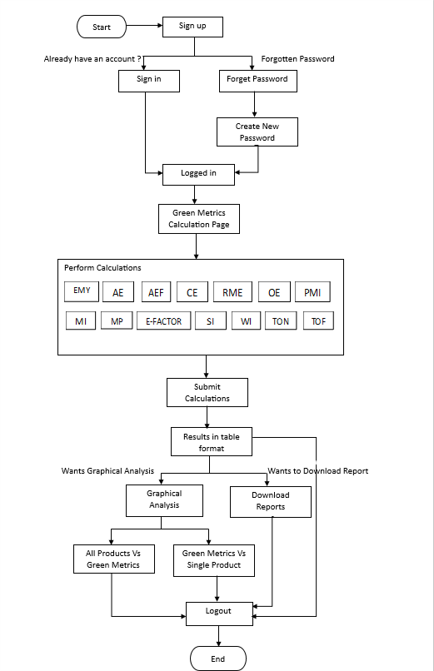

**3.2 Data Flow Diagram (0 level):**

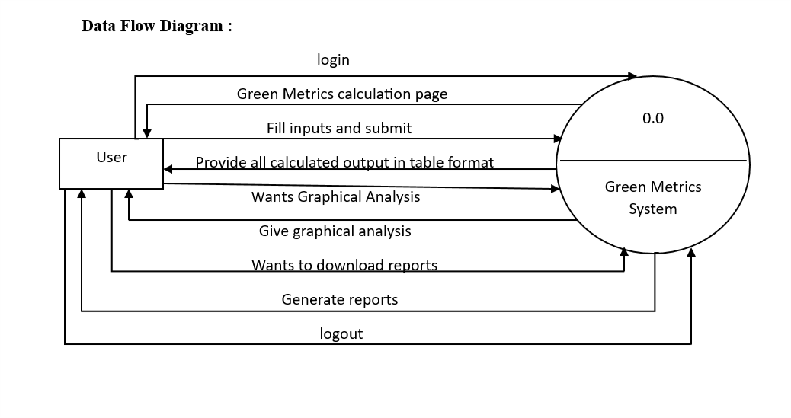

**3.2Entity Relationship Diagram:**

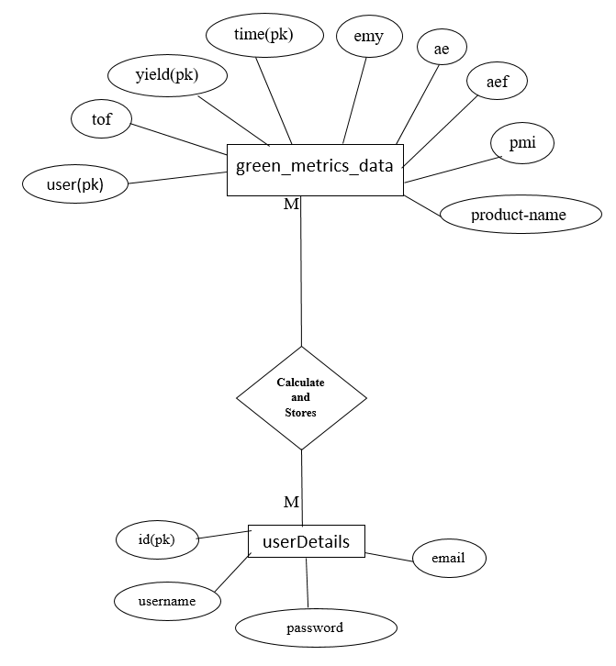

**3.4 Use case Diagram:**

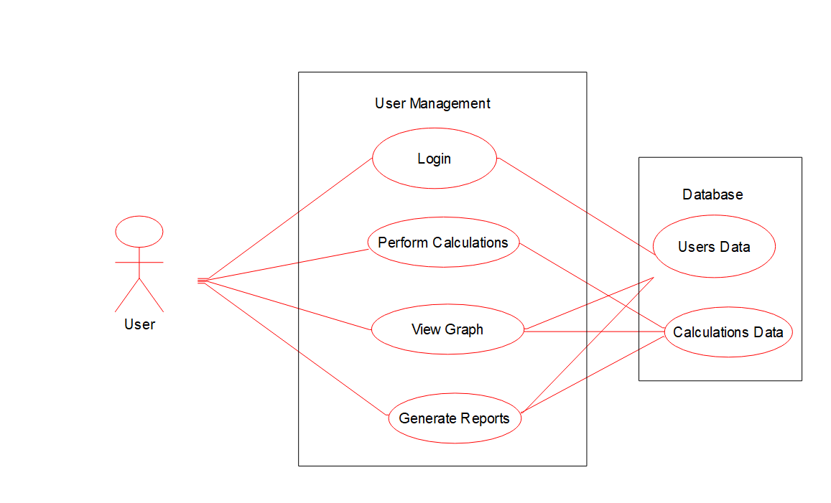

**SYSTEM DESIGN**

**4.1 Database Design:**

**Tables:**

* **userDetails :** For storing information of users
* **green_metrics_Data :** For storing all green metrics calculations for specific product name and generating reports according to username.

**1. Table Name: User Details**

|  |  |  |  |
| --- | --- | --- | --- |
| **Field Name** | **Data Type** | **Description** | **Constraint** |
| id | int | User Id | Primary key  auto-increment  Not null |
| username | varchar(50) | User name | Not null |
| password | varchar(50) | User password | Not null |
| email | varchar(50) | User email | Not null |

**2. Table Name: green_metrics_Data**

|  |  |  |  |
| --- | --- | --- | --- |
| **Field Name** | **Data Type** | **Description** | **Constraint** |
| product-name | varchar(40) | Product name | Primary key  Not null |
| yeild | float | Product yield | Primary key  Not null |
| time | float | Product time | Primary key  Not null |
| emy | float | Effective Mass Yield | Not null |
| ae | float | Atom Economy | Not null |
| aef | float | Atom Efficiency | Not null |
| ce | float | Carbon Efficiency | Not null |
| rme | float | Reaction Mass Efficiency | Not null |
| oe | float | Optimum Efficiency | Not null |
| pmi | float | Product Mass Intensity | Not null |
| mi | float | Mass Intensity | Not null |
| mp | float | Mass Productivity | Not null |
| e-factor | varchar(40) | E-Factor | Not null |
| si | float | Solvent Intensity | Not null |
| wi | float | Water Intensity | Not null |
| ton | float | Turn Over Number | Not null |
| tof | float | TurnOver Frequency | Not null |
| user | varchar(40) | Username | Primary key  Not null |

**INPUT SCREEN**





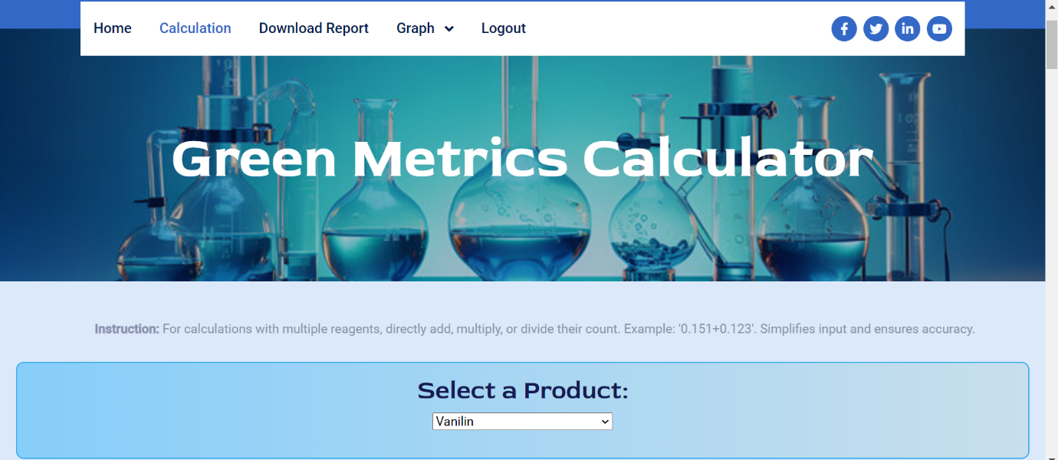

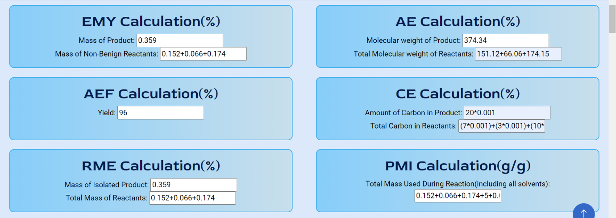

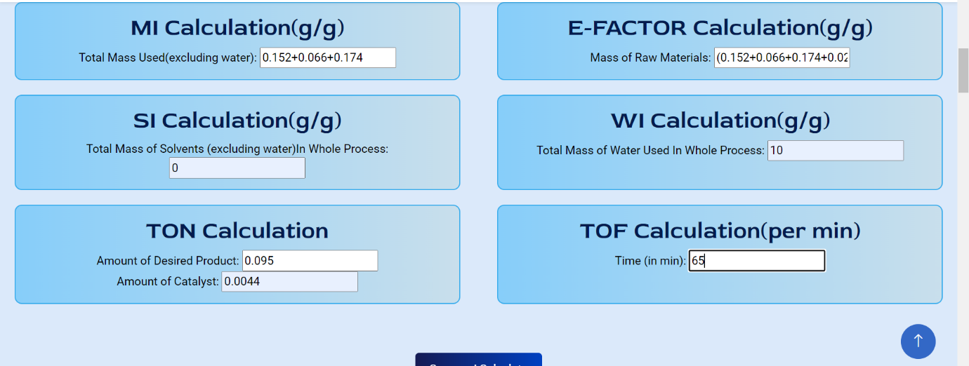

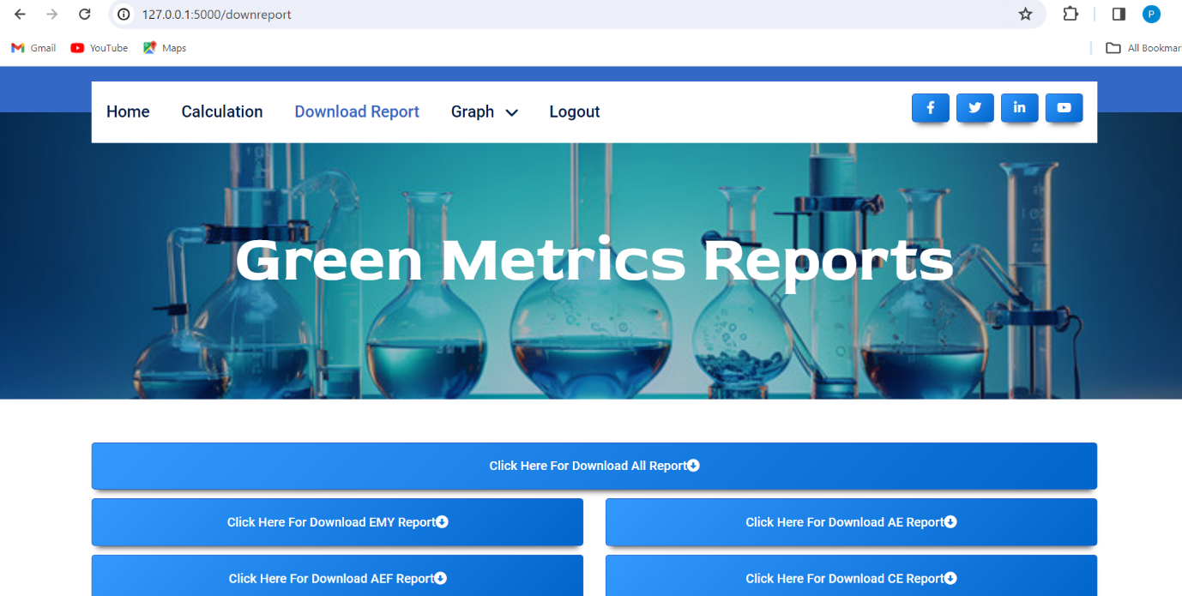

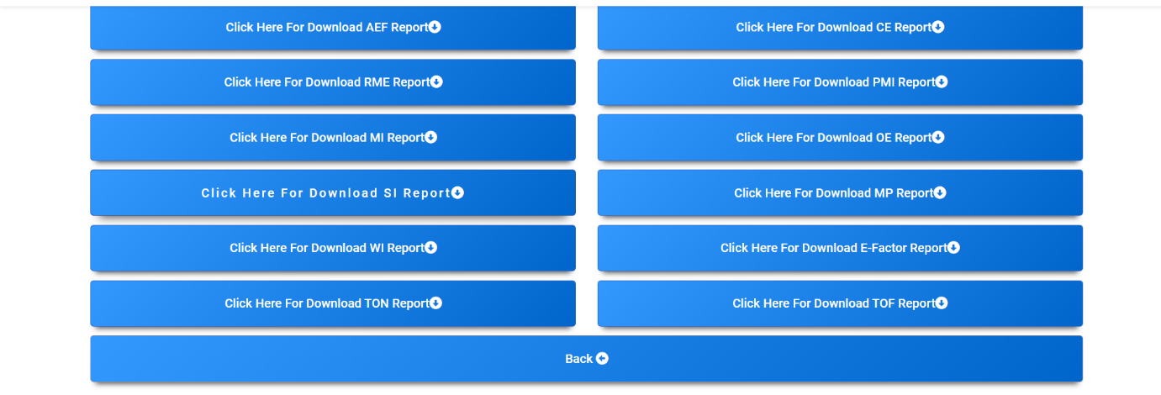

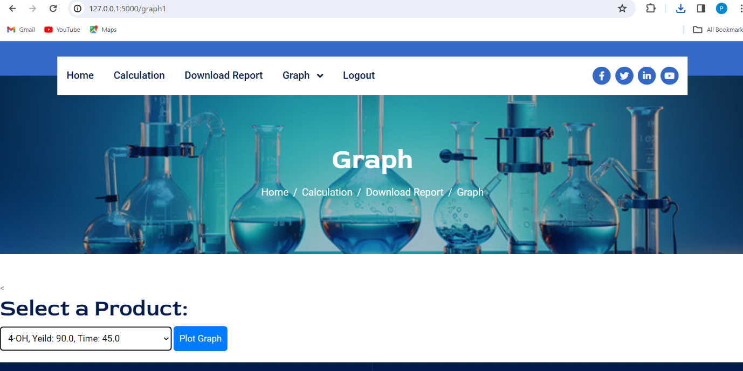

**OUTPUT SCREEN**

**Green Metrics Calculations:**

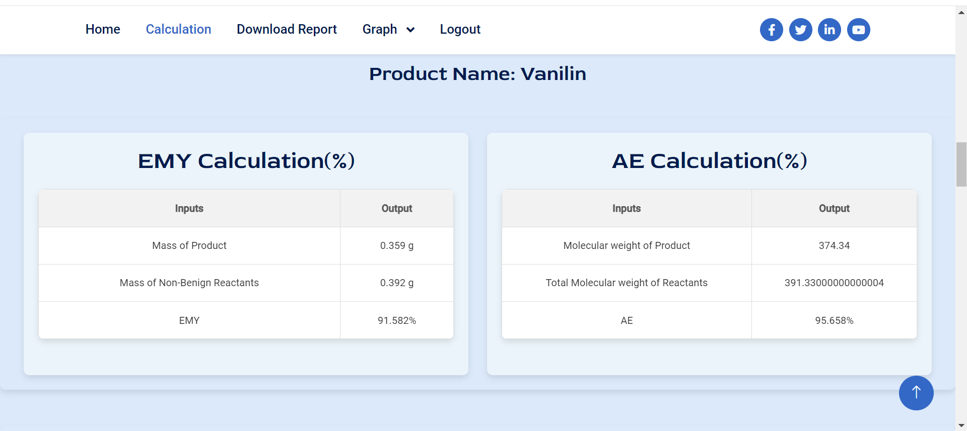

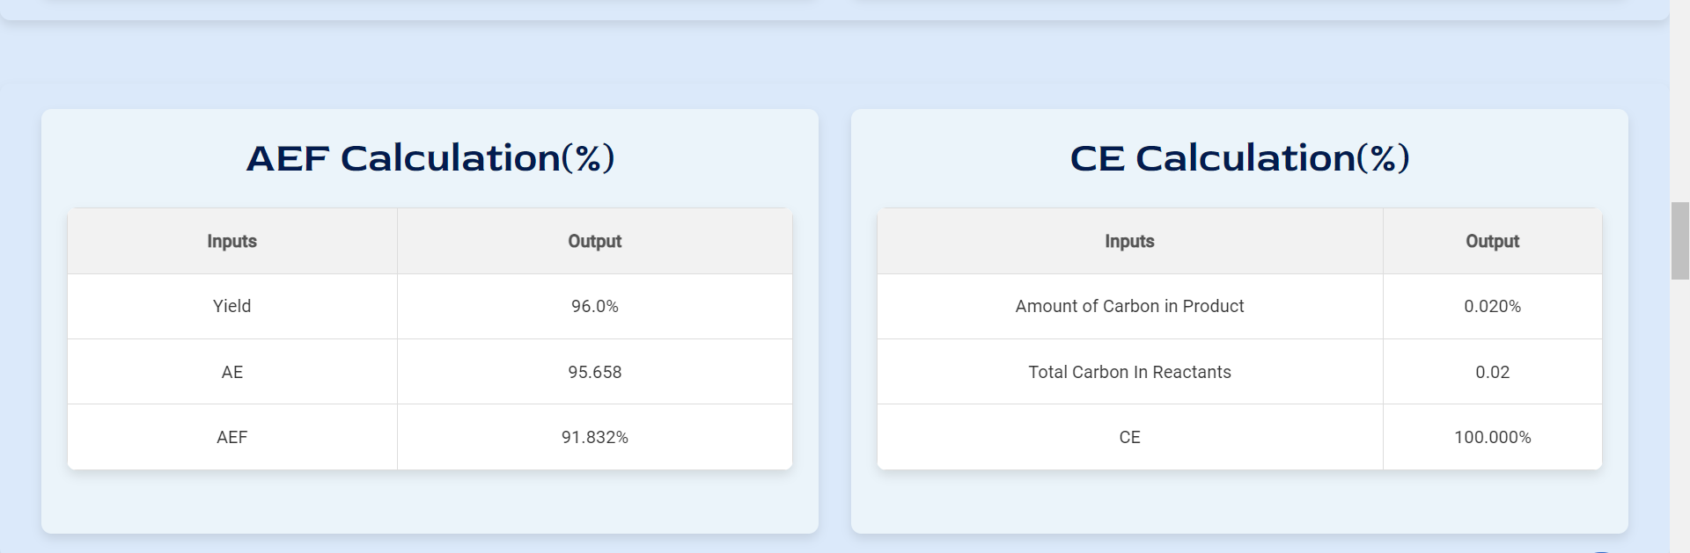

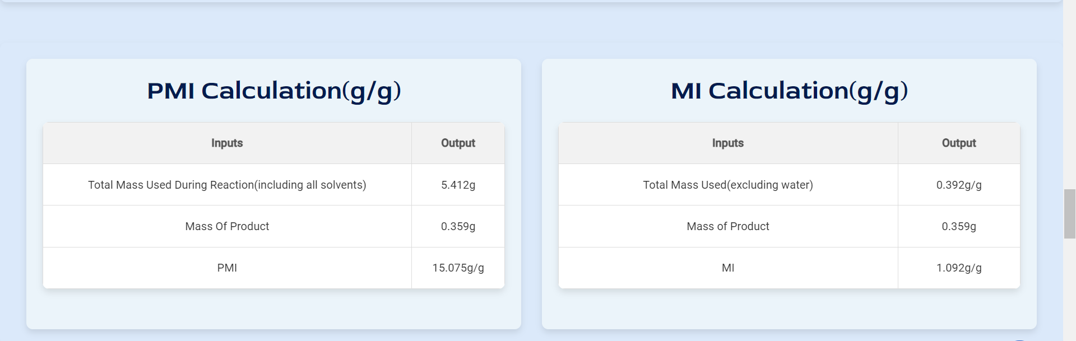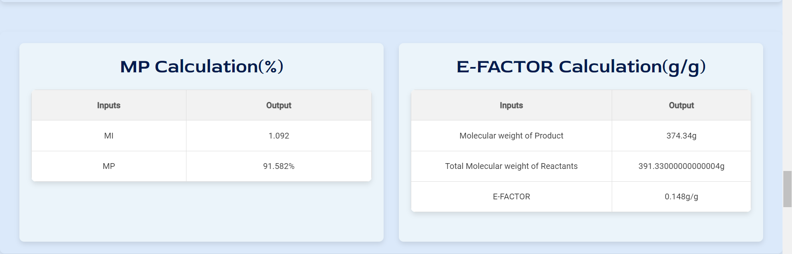

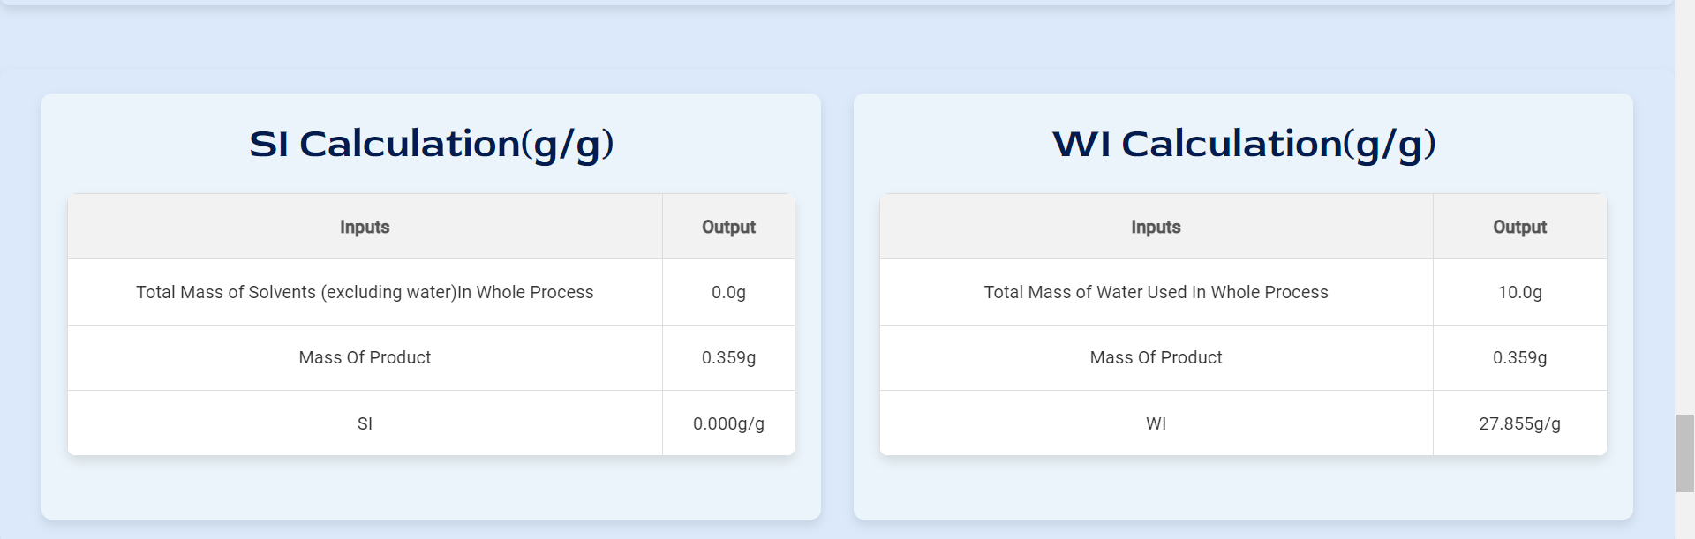

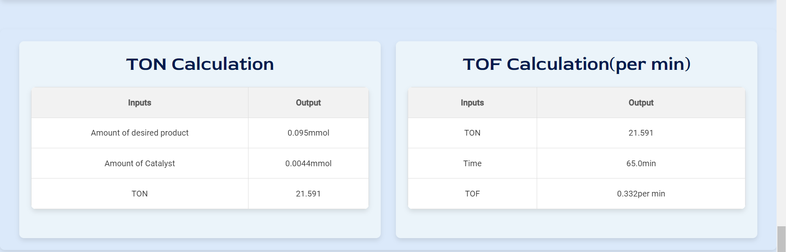

**Graphical Analysis:**

**1.Single Product v/s All Green metrics:**

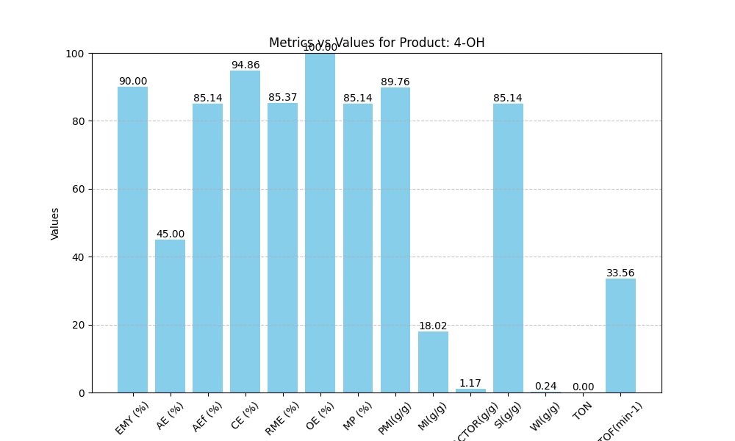

**2.All product v/s Single Green Metrics:**

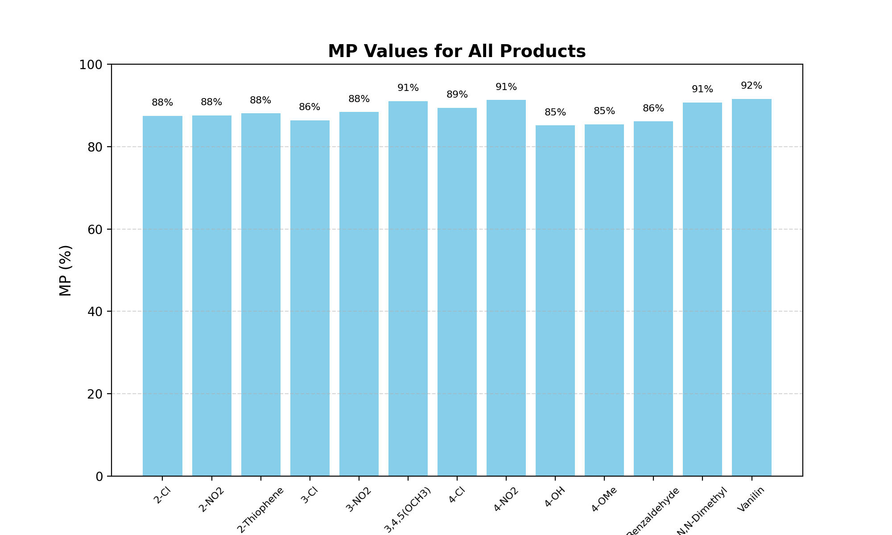

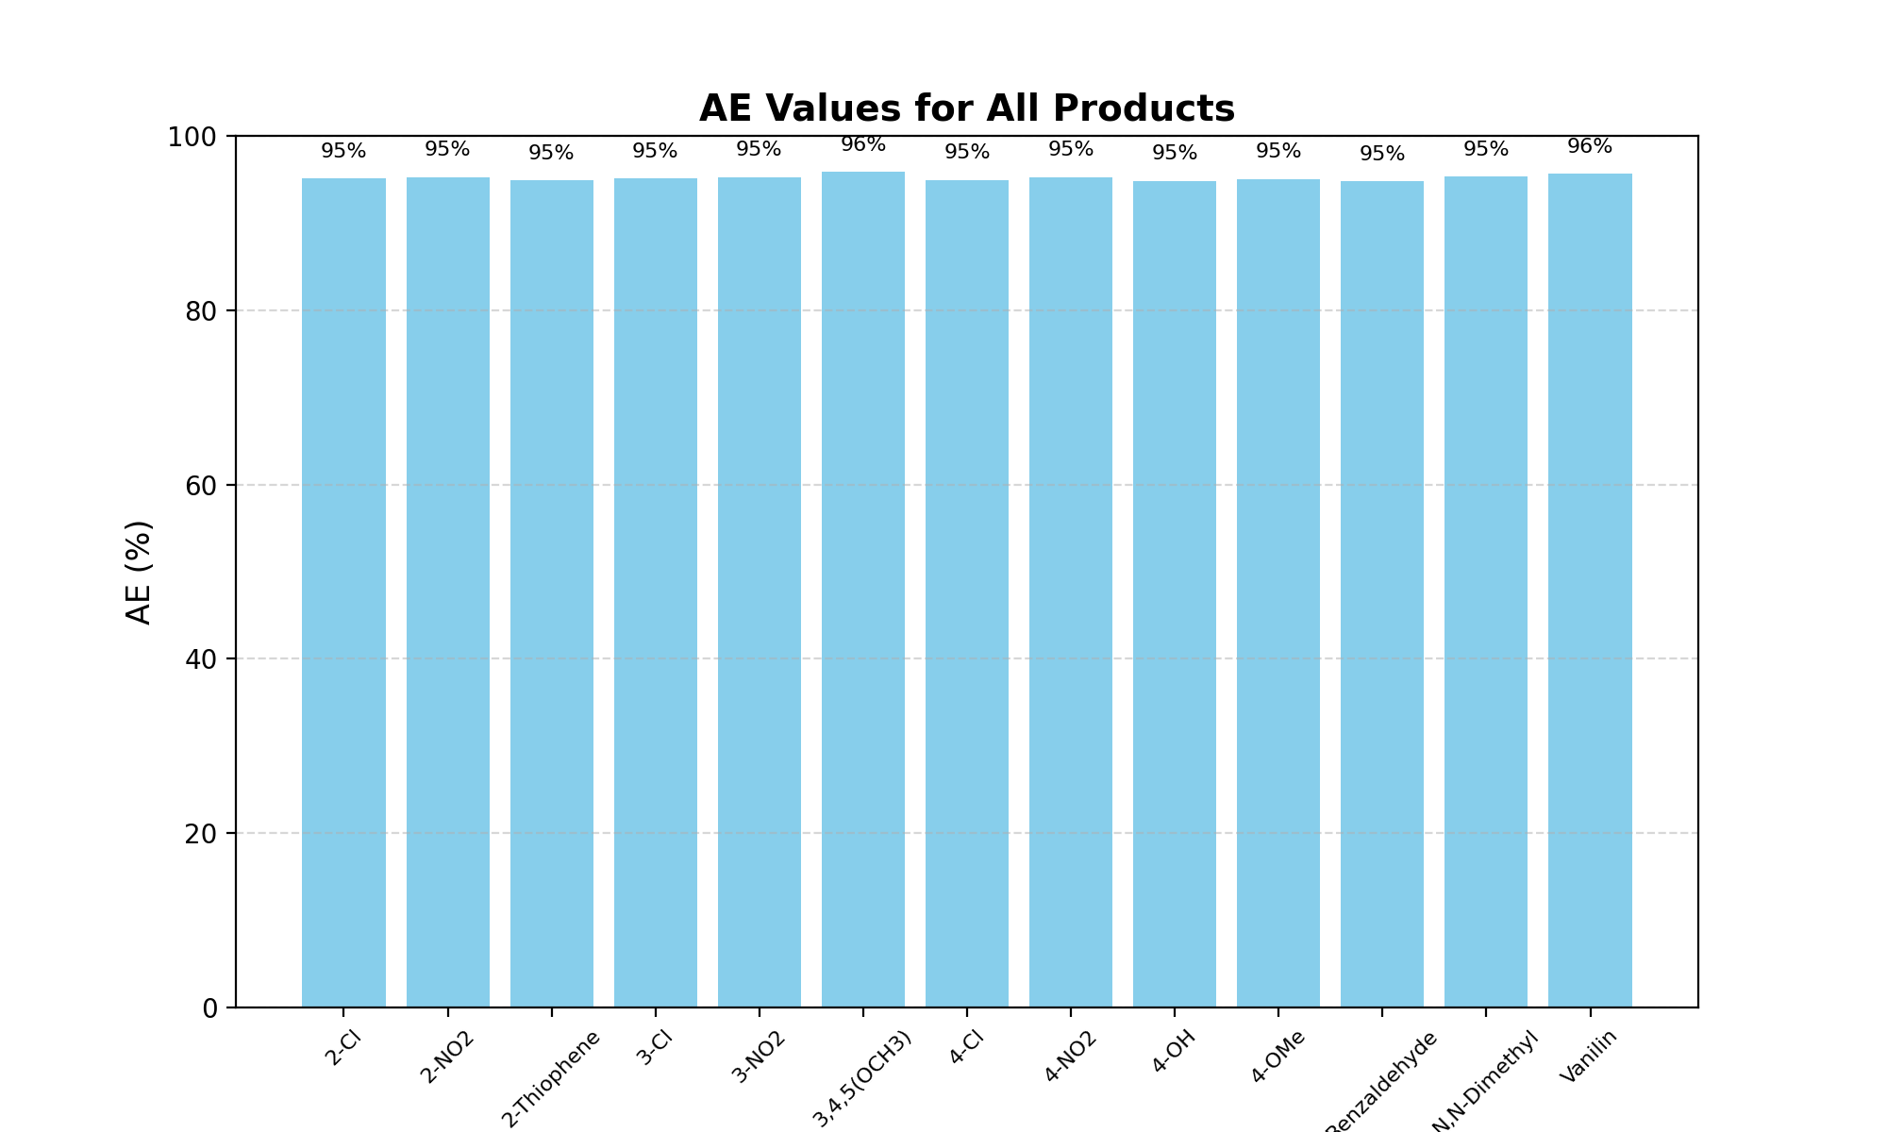

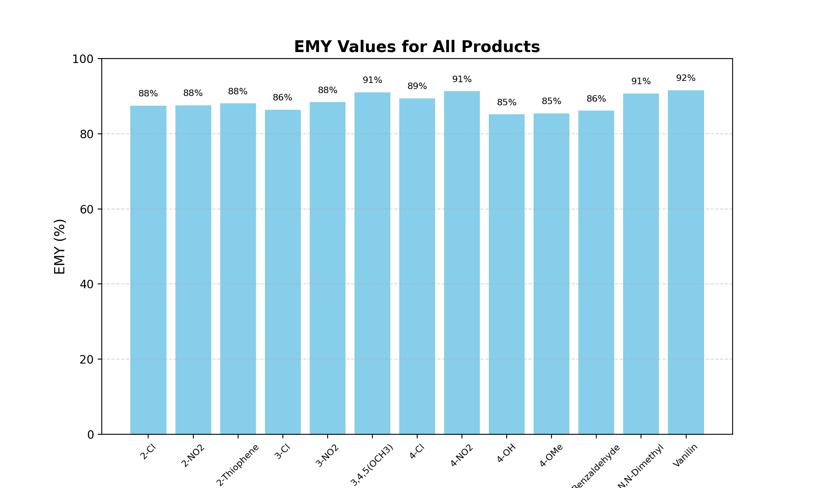

**REPORTS**

**1. Reports for all Chemical Products:**

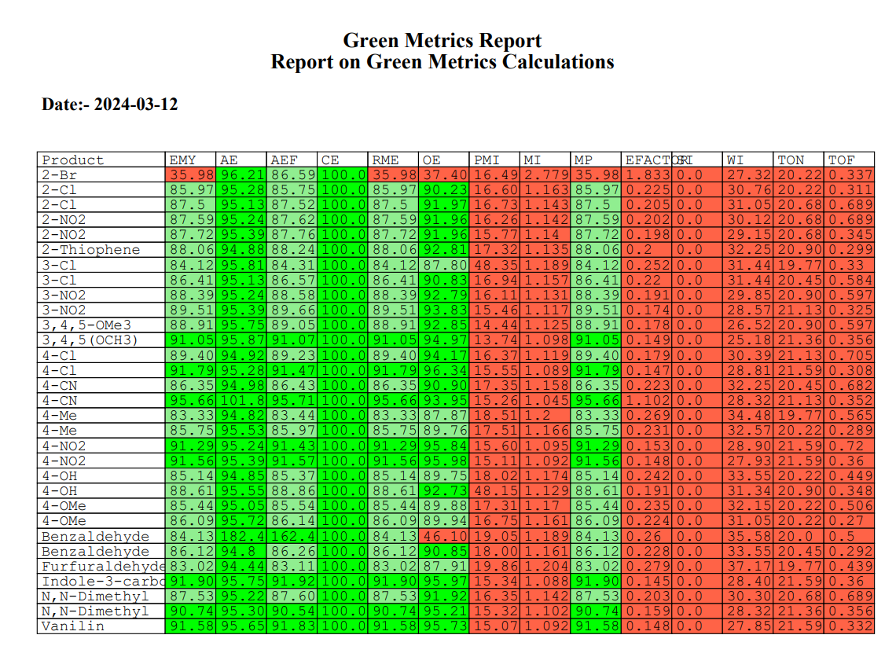

**Limitations of project on Online Portal for Green Metrics Calculations and Analyser:**

**1. Data Quality and Availability:** Emphasize the dependence of the software's accuracy on the quality and availability of input data. Discuss potential challenges in obtaining reliable data, such as inconsistencies in data sources or gaps in data coverage, which may limit the software's effectiveness in providing accurate environmental assessments.

**2. Scope and Coverage:** Highlight any limitations in the scope and coverage of the software in terms of the environmental metrics it can analyse and the industries or sectors it can serve effectively. Discuss any specific metrics or sectors that may not be adequately addressed by the current version of the software, limiting its applicability to certain users or contexts.

**3. Resource Requirements**: Evaluate the resource requirements associated with deploying and maintaining the software, including computing power, storage, and ongoing support and maintenance. Discuss potential challenges for organizations with limited resources or infrastructure, which may limit their ability to fully leverage the software's capabilities**.**

**Conclusion**

The **Online Green Metrics Calculations and Analyser** project promises to revolutionize environmental impact assessment by providing a user-friendly platform for calculating and tracking sustainability metrics. Its automated calculations and customizable parameters offer significant time savings and accuracy improvements, empowering users to make informed decisions towards environmental stewardship. With its comprehensive features and benefits, the ‘Online Green Metrics Calculations and Analyser’ has the potential to become an indispensable tool for businesses and organizations striving for sustainable practices.

* The Online Green Metrics Calculations and Analyser’ project addresses the growing need for efficient and accurate environmental impact assessment in today's business landscape.
* Its automated calculations streamline the process of measuring and tracking sustainability metrics, saving valuable time and resources for users.
* Customizable parameters allow users to tailor their analyses to specific requirements and industry standards, ensuring relevance and accuracy.
* The software's intuitive data visualization tools enable users to interpret and communicate their results effectively, facilitating informed decision-making.
* With its focus on environmental stewardship and responsible resource management, the Online Green Metrics Calculations and Analyser’ aligns with global efforts towards sustainability and green chemistry principles.

**Bibliography:**

* [**https://www.w3schools.com/**](https://www.w3schools.com/)
* [**https://www.geeksforgeeks.org/**](https://www.geeksforgeeks.org/)
* [**https://www.tutorialspoint.com**](https://www.tutorialspoint.com)
* [**https://www.youtube.com/**](https://www.youtube.com/)
* [**https://en.wikipedia.org/wiki/Green_chemistry_metrics**](https://en.wikipedia.org/wiki/Green_chemistry_metrics)

**Research paper (by Archana Rajmane Maam)**

* [**https://scholar.google.com/citations?view_op=view_citation&hl=en&user=403UyOAAAAAJ&citation_for_view=403UyOAAAAAJ:zYLM7Y9cAGgC**](https://scholar.google.com/citations?view_op=view_citation&hl=en&user=403UyOAAAAAJ&citation_for_view=403UyOAAAAAJ:zYLM7Y9cAGgC)

**Thank-You**